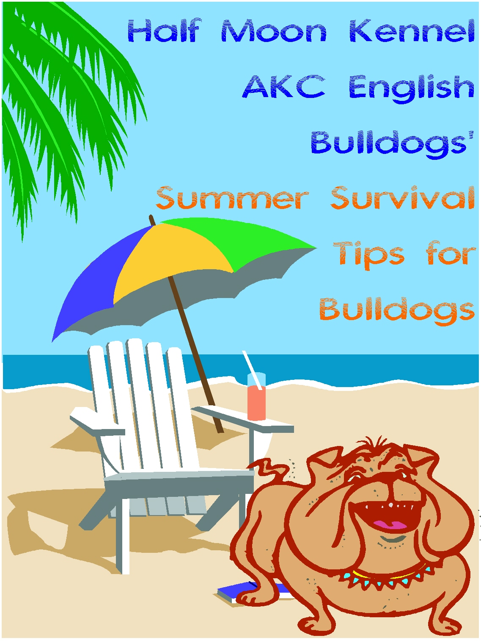

www.halfmoonkennel.com
halfmoonkennel@aol.com
850-974-2259


But bulldogs DON’T. Most bulldogs are not acclimated to weather changes, either very cold to very hot temperatures. So the best way to make sure your bulldog doesn’t get overheated is to practice prevention! While we humans may enjoy the warm weather that spring and summer bring, bulldogs usually do not fare well in hot and humid conditions. But, you can still enjoy summer fun by taking a few precautions and preventative measures to ensure that you AND your bulldog have a safe summer!

Bulldogs can die from overheating. Bulldogs do not even have to be active to succumb to overheating, so don’t kid yourself that just because your bulldog is just lying in the sun that he can’t become too hot. Bulldogs don’t know when enough is enough. So make sure that any exercises, such as walks or play, are given early in the morning or late in the evening. Those sunny, Sunday afternoon strolls are great for humans, but don’t take your bulldog with you when it is very sunny or hot or humid. Also please don’t allow your bulldog to lie out in the sun for long periods, they do not know when they have had enough and it doesn’t take long for their panting to become out of control.

How do you know if your bulldog’s panting is out of control? Your bulldog’s panting will become more like heaving. This is the earliest sign that your bulldog is overheating; if the heaving becomes loud -- to almost a roaring sound, your bulldog has gotten too hot and the outcome could be dangerous and even fatal.

**Stages of overheating:
- Your bulldog will begin to "heave" as he pants
- Your bulldog will begin to "roar" - best described as sounding like severe asthma
- He will begin to look tired and distressed
- His tongue will be very floppy and very red in color
- His body temperature will rise (normal temp approx 38.6)
- His airway will swell and his throat become full of white foam (caused through the excessive panting)
- He will quickly become exhausted and will fighting for breath
- He could die
**Steps you can take if your bulldog is overheating:
First and foremost, remain calm. If you get excited and upset, your bulldog will too.
- Lower the body temperature: Always ensure that you have ice on hand during the summer months. Pour cold water over your dog, especially around his head; rub ice around his head and under his tail (around his rectum). If possible stand him in a cold bath and keep going with the ice until the breathing is less labored. If possible, stand him in a tub of cold water and pour/ shower the cold water over his body, especially his head until his breathing is much calmer. Dogs expel heat from their foot pads; therefore standing him in cool water will enhance overall cooling.
- Clear the airway: Squirt some lemon juice (from one of those plastic lemon shaped bottles) into the back of his throat; he will hate you for it, but the lemon juice will quickly break up the excess foam and clear the throat. Do not allow him to drink a lot of water as this can cause him to vomit.*
- Keep him calm: Once you have reduced his panic keep him in a quiet place and keep a close eye on him.
- If this doesn’t work then you need to get to a vet as quickly as possible - put a cold damp towel under him for the journey
*DON'T force an overheating dog to drink water. Offer the water, but if refused don't force the issue. You may use a syringe or a water bottle with a squeeze cap to place water, Gatorade or a glucose (sugar) solution in his mouth, but DO NOT SQUIRT IT DOWN HIS THROAT. He could suck it down the wrong tube, get it into his lungs and choke to death. He must lick it. Place it in the corner of his mouth/ on his tongue and ensure that he licks it.
Keep the following on hand:
- Plenty of ice
- Plastic lemon - Lemon Juice
- If you need to go out freeze some damp towels the day before and take with you together with both of the above items and plenty of cold water.
- Isopropyl Alcohol
In an emergency you can substitute 7UP for the lemon and packets of frozen veggies for the ice. Some people will offer Coke or Red Bull. If outdoors, find a horse trough, stream, river or pond to stand your dog in. At home, you can also use a large ice chest or cooler or your bathtub. Some people suggest saturating the bulldog’s back with isopropyl alcohol, as this will cool him fast. Be very cautious…alcohol burns, so don’t get any in your bulldog’s eyes and be cautious to use it if your bulldog has open sores, cuts, or abrasions as the alcohol could burn and cause your bully to become upset or excited. Remember overheating can happen at any time, even if up until now he has coped perfectly OK with the heat. Prevention is much better than cure.
** Stress can often bring on the same symptoms and should be treated in the same way as described above.



SUMMER PRECAUTIONS
Have fresh cool water available to your bulldog at all times. Some bulldoggers suggest ½ teaspoon of apple cider vinegar in his water to help to keep the phlegm levels down.
Use common sense. If it is comfortable for you it is comfortable for him. If you are hot, your bulldog is hotter. Imagine triple digit temps covered in fur!! Typically 85 degrees F and above are considered hazardous to bulldogs.
If you are not home DON'T let your bulldog have free access to the yard. Bulldogs love the sun. He will sun bathe and overheat before he realizes it and you won’t be there to save him.
Provide a cool shaded place inside with a fan blowing to circulate air in the room. Do not give him direct access to air condition vents blowing directly on him. This could cause him to get sick. Bulldogs love cool floors such as tile.
Don't let your bulldog go out unsupervised in warm months even to go potty because he may lie out in the sun. It is best to bring him straight back in again once he has gone potty. Spray him with cool water from a water bottle if necessary to keep his skin cool.
NEVER leave your Bulldog (or any other animal) in the car, even if it is running or the windows are down/cracked. It only takes 2 minutes for him to suffer heat exhaustion if the conditions are right.
NEVER walk your Bully in hot weather or very cold weather. Bulldogs often walk out but expect to be carried back. If you must, do it at times of the day in warm months that are comfortable, such as early morning or in the evening. Keep in mind that the roads, sidewalks, and sand can be very hot. Always place the backside of your hand on the surface to test the heat. If it burns your hand, just think what it is doing to your bulldog’s feet and pads!
Brushing your bulldog helps to circulate air between their coat and their skin.
Darker haired dogs absorb heat quickly, so take precautions to keep them out of the sun and heat. Light haired/white dogs may be prone to sunburn.
The two most important things you can offer your bulldog are SHADE and FRESH COOL WATER!
If you’re interested in products to help keep your bulldog cool this summer, you can invest in things like pet fountains, pet tents, and temperature controlled beds. Less expensive household items can also provide your bulldog with cool comfort during hot summer months. Keep jugs of frozen water wrapped in a towel near or in your bulldog’s bed!
If you’re traveling with your bulldog, a kennel is invaluable. Keep your emergency items handy and accessible: even when traveling, your bulldog can become overheated or stressed.
Identify your bulldog so that if he gets lost or gets away from you, you have a greater chance of bringing your bulldog home. Remember, bulldogs are expensive and you should be cautious of thieves, whether while traveling or in your own backyard!

 BEACHES AND BULLDOGS
Apply sun block to ears and nose of your bulldog 30 minutes before going outside. If your bulldog is white, they are more likely to need more sun block.

While at the beach, or even by the pool, keep fresh, cool drinking water available at all times for your bulldog. Provide lots of shade to prevent overheating.
Check the beach conditions. If beach warning flags indicate dangerous conditions or marine pests, think twice about letting your bulldog in the water. Bulldogs are easy prey for jellyfish and other parasites, including lice.
Not all bulldogs can swim! Don’t assume your bulldog can. Some bulldogs cannot stay afloat because of their build and body structure. Always supervise your bulldog in the water; it is best to stay in shallow areas. Be prepared to move quickly if your bulldog begins to flounder.
Summer and insects go hand in hand. Keep Benadryl on hand for insect bites. However, if your bulldog is suffering from severe bites from wasps, bees, mosquitoes, ants, or other insects, seek medical attention right away! Your bulldog could suffer an allergic reaction.
Be careful of head injuries while playing and enjoying the summer fun. These can be fatal to your bulldog. Seek medical care. We want you and your bulldog to enjoy the summer so you can both enjoy the fall, winter and spring seasons together!

We Hope You’ll Have a Safe Summer With Your Bulldog!


Thanks for downloading “Half Moon Kennel AKC English Bulldogs’ Summer Survival Tips Handbook”.
http://www.halfmoonkennel.com
halfmoonkennel@aol.com

